Assignment #4

Question#1:

#include<iostream>

#include<cstdlib>

#include<time.h>

using namespace std;

void myfunction(int dice1, int dice2, int sum, int count, int num)// Making a void function //

{

srand(time(0));//Generating random Number//

sum = -1;

while (num != sum)//Loop for that Numbers //

{

dice1 = rand() % 6 + 1;

dice2 = rand() % 6 + 1;

sum = dice1 + dice2;//sum//

cout << sum << " ";//Displaying sum//

count++;

}

cout << "\n";

cout << "The Number of turns is = " << count;//No of Terms //

cout << endl;

}

int main()

{

int num, dice1 = 0, dice2 = 0, count = 0, sum = -1;//itializing somr=e variables //

cout << "Enter the Number : ";//taking Input//

cin >> num;

myfunction(dice1, dice2, sum, count, num);//calling the function//

system("pause");

return 0;

}

Output:

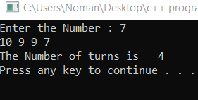

Question #2:

#include<iostream>

using namespace std;

void largest(int arr[6])//Making function and Passing 1D array as a arguments//

{

int Max=0,i;

for ( i = 0; i < 6; i++)//This For loop will goes to each number //

{

if (arr[i] > Max)//And This Condition Check the Largest Number //

{

Max = arr[i];

}

}

cout << "The largest is " << Max << endl;//displaying //

}

void smallest(int arr[6])

{

int smallest = arr[0];//Intilizing index of array with zero//

for (int i = 0; i < 6; i++)

{

if (arr[i] < smallest)//This Condition is For Smallest number //

{

smallest = arr[i];

}

}

cout << "The smallest is " << smallest << endl;

}

int main()

{

int arr[6] = { 9,8,5,4,6,2 };//taking an 1d array

largest(arr);

smallest(arr);

system("pause");

return 0;

}

Output:

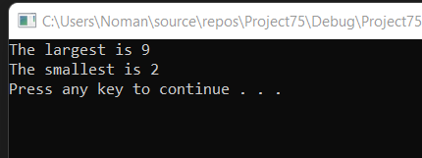

Question #3:

#include<iostream>

#include<ctime>

using namespace std;

void radius(int x1, int x2, int y1, int y2)//Making a function of Type Void//

{

double radius;

cout << "Enter the value of x1 to find radius:";//Taking Input//

cin >> x1;

cout << "enter the value of x2 to find radius :";

cin >> x2;

cout << "enter the value of y1 to find radius :";

cin >> y1;

cout << "Enter the value of y2 to find radius :";

cin >> y2;

radius = ((x2 - x1)*(x2-x1)) + ((y2 - y1)*(y2-y1));//Making formula To find radius//

cout << sqrt(radius) << endl;//taking square root of that radius//

}

int area(double radius)//To find area we have formula pi*r*r//

{

double area1, pi = 3.14;

cout << "Enter the radius to find area : ";

cin >> radius;

area1 = (3.14)*(radius*radius);//This is formula to find area//

cout << "The area is : " << area1 << endl;

return area1;

}

void circumference(double radius)//Making function for circumfrence//

{

double fcircum;

cout << "Enter the radius to Find circumference :";

cin >> radius;

fcircum = (2 * 3.14)*radius;

cout << "The circumference of the Circle is : " << fcircum;

cout << "\n";//for next line//

}

void distance(int x1, int x2, int y1, int y2)//Making a function of Type Void//

{

double distance;

cout << "Enter the value of x1 to find distance :";//Taking Input//

cin >> x1;

cout << "enter the value of x2 find distance :";

cin >> x2;

cout << "enter the value of y1 find distance :";

cin >> y1;

cout << "Enter the value of y2 find distance :";

cin >> y2;

distance = ((x2 - x1)*(x2 - x1)) + ((y2 - y1)*(y2 - y1));

cout << "The distance between two points is : " <<sqrt (distance) << endl;//Displaying Distance//

}

int main()

{

int a=0, b=0 ,c=0, d=0,g=0,r=0,num1=0,num2=0,num3=0,num4=0;//Intializing some variables with zero//

radius(a, b,c, d);//Calling the radius Functio//

area(g);//calling the area function//

circumference(r);//calling the circumference function//

distance(num1, num2, num3, num4);//calling the distance function//

system("pause");

return 0;

}

Output:

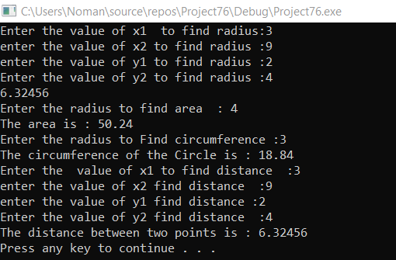

Question #4:

#include<iostream>

#include<fstream>

#include<string>

using namespace std;

int main()

{

ifstream in;

ofstream out;

string name[3],section[3];

int rollNo[3], i = 0;

float gpa[3];

out.open("file.txt",ios::app);

/*name = "My Name is umer ";

out << name;*/

out.close();

in.open("file.txt");

char ch;

//string name;

while (!(in.eof()))

{

in >> name[i] >> rollNo[i] >> gpa[i] >> section[i];

i++;

}

for(int i=0;i<3;i++)

cout << name[i] << " " << rollNo[i] << " " << gpa[i] << " " << section[i] << endl;

rollNo[1] = 9104;

for (int i = 0; i < 3; i++)

cout << name[i] << " " << rollNo[i] << " " << gpa[i] << " " << section[i] << endl;

}

Output:

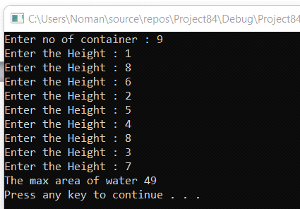

Question #5:

#include<iostream>

#include<string>

using namespace std;

int myfunction(string str);

int main()

{

int result;

string str;

cout << "Enter a String ";//Takin Input a string//

cin >> str;

result = myfunction(str);//calling the myfunction//

cout << result << " ";//dispalying the Returning value//

for (int i = 0; i < result; i++)

{

cout << str[i];//Displaying the string //

}

system("pause");

return 0;

}

int myfunction(string str)

{

bool found = false;//It will break the Following both Loops //

int result1,count=1;//decalreand intializing//

result1 = str.length();//storing Length of String in a variable //

for (int i = 0; i < result1; i++)

{

for (int j = 1; j <= result1; j++)

{

if (str[i] == str[j])

{

found = true;

break;

}

else

{

count++;

}

}

if (found==true)

{

break;

}

}

return count;

system("pause");

}

Output:

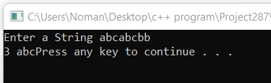

Question #6:

#include<iostream>

using namespace std;

int firstpro(int arr[], int size);

int secondpro(int arr[], int size);

int Thirdpro(int arr[], int size);

int fourthpro(int arr[], int size);

int fifthpro(int arr[], int size);

int main()

{

cout << "...................WELCOME TO MENU DRIVEN PROGRAM WHICH WILL PERFORM DIFFERNT FUNCTION................" << endl;

cout << "press 1 to give input in an array" << endl;

cout << "press 2 to give number at start " << endl;

cout << "press 3 to give number at end" << endl;

cout << "press 4 to give specific number and deleting Number" << endl;

cout << "press 5 to give non zero values in array" << endl;

cout << "press 6 to exit program" << endl;

bool found = true;

while (found)

{

int input, temp = 0;

const int size = 100;

int arr[size];

cout << "Enter Number between 1 and 6 according to above information" << endl;

cin >> input;

if (input == 1)

{

firstpro(arr, size);

}

if (input == 2)

{

secondpro(arr, size);

}

if (input == 3)

{

Thirdpro(arr, size);

}

if (input == 4)

{

fourthpro(arr, size);

}

if (input == 5)

{

temp = fifthpro(arr, size);

cout << "Non zero Numbers in the array:" << temp << endl;

}

if (input == 6)

{

exit(0);

}

}

}

int firstpro(int arr[], int size)//function for taking inputs//

{

cout << "Enter 20 numbers" << endl;

for (int i = 0; i < 20; i++)

{

cin >> arr[i];

}

for (int i = 20; i < size; i++)

{

arr[i] = 0;

}

for (int i = 0; i < size; i++)//Displaying that Numbers of array

{

cout << arr[i] << " ";

}

cout << endl;

return 0;

}

int secondpro(int arr[], int size)//function for placing a number at start//

{

int num;

cout << "Enter a number for placing it at first" << endl;

cin >> num;

int totallength = size;

for (int j = size - 2; j >= 0; j--)//loop for shifting arrays elemnts//

{

arr[totallength - 1] = arr[j];

totallength--;

}

totallength = 5;

arr[0] = num;

for (int i = 0; i < size; i++)

{

cout << arr[i] << " ";

}

cout << endl;

return 0;

}

int Thirdpro(int arr[], int size)//function for placing a number at End//

{

int n;

cout << "Enter a number for placing it at last" << endl;

cin >> n;

arr[size - 1] = n;

for (int i = 0; i < size; i++)

{

cout << arr[i] << " ";//Diplaying array Number of Last Index/

}

cout << endl;

return 0;

}

int fourthpro(int arr[], int size)//Take a specific index//

{

int num, specific_index;

cout << "Enter specific index" << endl;

cin >> specific_index;

cout << "Enter number" << endl;

cin >> num;

arr[specific_index - 2] = arr[specific_index - 1];

arr[specific_index - 1] = arr[specific_index];

arr[specific_index] = num;

for (int i = 0; i < size; i++)

{

cout << arr[i] << " ";

}

cout << endl;

cout << "Deleting the Number " << endl;

cout << "The updated array is !." << endl;

for (int i = 0; i < size; i++)//Displaying updated array after deleting//

{

if (arr[i] == num)

{

continue;

}

cout << arr[i] << " ";

}

cout << endl;

return 0;

}

int fifthpro(int arr[], int size)

{

int count = -1;

for (int i = 0; i < size; i++)//for finding the number of non zero integers in array//

{

if (arr[i] != 0)

{

count++;

}

}

return count;

cout << endl;

}

Output:

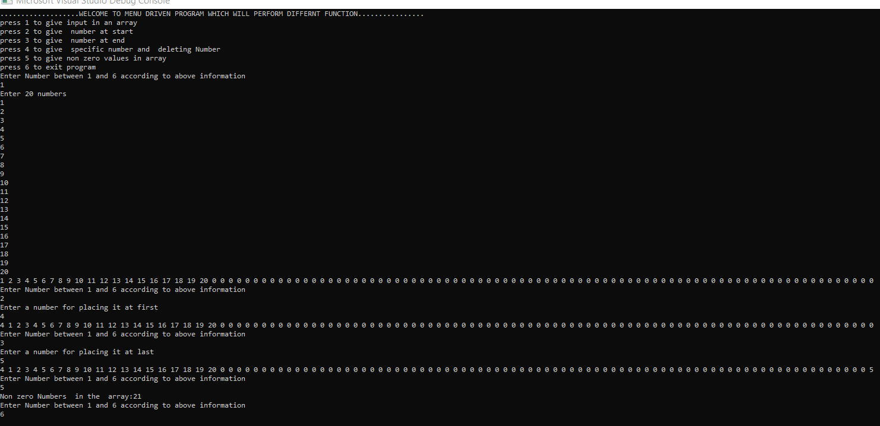

Question #7:

#include<iostream>

#include<string>

#include<cstdlib>

using namespace std;

int KaprekarsConstant(int arr[4]);

int main()

{

int vari = 0;

int arr[4];//declaring an array of Size4//

cout << "Enter a four digits one by one " << endl;

for (int i = 0; i < 4; i++)//Taking input//

{

cin >> arr[i];

}

vari = KaprekarsConstant(arr);

cout << vari;

}

int KaprekarsConstant(int arr[4])

{

int n1, n2, n3, n4, helper1, helper2, helper3, helper4;//declaring some variables//

int static count = 1;

int temp = 0;

bool x = true;

while (x)

{

//process of asscending//

for (int i = 0; i < 4; i++)

{

for (int j = 0; j < 4 - 1; j++)

{

if (arr[j + 1] < arr[j])

{

temp = arr[j + 1];

arr[j + 1] = arr[j];

arr[j] = temp;

}

}

}

int asc = 0;

asc = arr[0];

for (int i = 1; i < 4; i++)

{

asc *= 10;

asc += arr[i];

}

cout << "ascending = " << asc << endl;

//process of descending//

for (int i = 0; i < 4; i++)

{

for (int j = 0; j < 4 - 1; j++)

{

if (arr[j + 1] > arr[j])

{

temp = arr[j + 1];

arr[j + 1] = arr[j];

arr[j] = temp;

}

}

}

int des = 0;

des = arr[0];

for (int i = 1; i < 4; i++)

{

des *= 10;

des += arr[i];

}

cout << "descending = " << des << endl;

//process of subtraction//

int sub;

sub = des - asc;

cout << "subtracted = " << sub << endl;

//process of seprating four digits

n1 = sub % 10;

helper1 = sub / 10;

n2 = helper1 % 10;

helper2 = helper1 / 10;

n3 = helper2 % 10;

helper3 = helper2 / 10;

n4 = helper3 % 10;

helper4 = helper3 / 10;

arr[0] = n1;//assigning Numbers to indexes of the array //

arr[1] = n2;

arr[2] = n3;

arr[3] = n4;

if (sub == 6174)

{

x = false;

}

else

count++;

cout << endl;

}

return count;//return Number of turns about constant Number //

}

Output:

